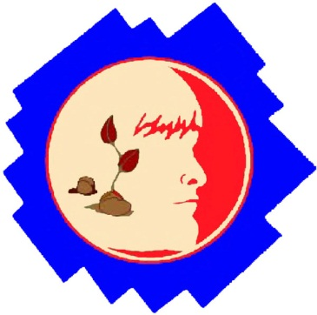
ODYSSEY OF THE MIND INFORMATION MEETING
Thursday, September 10th from 5:45 – 6:30 PM in MPR
PTA Association Meeting directly follows
PARENTS AND STUDENTS ARE INVITED TO FIND OUT MORE ABOUT THIS EXCITING PROGRAM.
Students in Grades 3-5 will compete. K-2 students can participate in a non-competitive exhibition.

What is Odyssey of the Mind?
Odyssey of the Mind is a creative problem-solving competition for K-college students where the kids come up with ALL of the ideas and do ALL of the work. Teams of up to 7 students select a problem, create a solution, then present their solution through an 8 minute skit in a competition against other teams in the same problem and division.
What is the time commitment?
Teams will compete in the Regional Competition on Sunday, Feb 22nd at El Camino High in Oceanside. Practice schedule is to be determined by team coach but will likely be one day per week for Oct & Nov with practices increasing to 2 times per week as the competition date nears.

Looking for a rewarding way to get involved in your child’s education?
We will need one team coach and one tournament judge for each team of 7 students. Each team selects one long-term problem. This is a fun learning experience that will challenge kids, promote confidence, build friendships and provide life-long memories. Coaches will choose their teams.

Can’t make the meeting but still interested?
Email Ami Lau for an interest form to be completed and returned by Monday, Sept 21. Forms can also be downloaded at http://adobebluffspta.com/odyssey-of-the-mind/.

Questions? Feel free to email Ami Lau at ami_lau@yahoo.com.

Go to www.odysseyofthemind.com for more info.

2015-2016 LONG-TERM PROBLEM SYNOPSES
All problems performed in skit format and have an 8-minute time limit.
Problem 1: No-Cycle Recycle (3rd-5th grade)
Teams will build, ride on, and drive a no-cycle, recycling vehicle. It will pick up discarded items, adapt them in some way, and then deliver them to places to be re-used. The vehicle must travel without pedaling for propulsion. In addition, the driver will have an assistant worker riding on the vehicle that will help process the trash items being repurposed. They will make an unplanned stop along the way to perform a random act of kindness.

Problem 2: Something Fishy (3rd-5th grade)
Teams will design and operate a technical solution that simulates multiple styles of fishing. A Fisher Character will work from a designated area to "catch" three different objects that are outside of that area. The catch will be on the move and will include something expected, something unexpected, and a new discovery. The performance will also include a change of weather and a humorous character that portrays a potential catch and avoids being caught by the Fisher.

Problem 3: Classics... Aesop Gone Viral (3rd-5th grade)
Teams will create and present an original performance about a fable gone "viral." The problem will include a list of fables attributed to Aesop. Teams will select one and portray it, and its moral, as going viral - that is, being shared throughout the community and beyond. The performance will be set in a past era and include a narrator character, an artistic representation of the fable's moral, and a character that makes a wrong conclusion about the moral and is corrected.

Problem 4: Stack Attack! (3rd-5th grade)
This problem requires teams to design, build, and test a structure, made only of balsa wood and glue that will balance and support as much weight as possible--twice. During weight-placement, teams can "Attack the Stack" where they will remove all of the weights except for the bottom one and the crusher board. Teams will also receive score for removing weights! After Attacking the Stack, the weight placement process can be repeated to add to the total weight held. Teams will incorporate weight-placement, repetition, and Attacking a Stack into the theme of the performance.

Problem 5: Fins, Furs, Feathers & Friends (3rd-5th grade)
The team's problem is to create and present a humorous performance depicting problem solving from the perspective of three different animals. The animals will help a stranger, help each other, and solve a problem that threatens the survival of all animals. During the performance, the animals will sing and dance. They will also show curiosity, sympathy, frustration, and joy.

Primary:Stir the Pot (Kindergarten – 2nd grade)
Teams will create and present a humorous performance about an object that comes to life when touched by an item that turns out to be magical. While it is alive, the animated object will encounter three other objects that will result in a dramatic change of behavior. There will be a narrator character that explains what is happening and a character that becomes friends with the object. The performance will also include a team-created poem, song, or dance.

