Dear Parents:

We are pleased to welcome award-winning children's author Scott Sussman to Adobe Bluffs Elementary School on Wednesday, February 1st. Students can purchase personally autographed books at discount prices by completing the order form below and returning CASH to their teachers by Wednesday, January 25th. More information on Scott and his books can be found at www.octopusinkpress.com.
We are all excited to have Scott Sussman join us and share in our love of literacy!

Silly the Seed  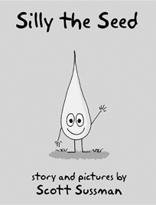  Silly learns that kind acts  lead to beautiful consequences. | Mark and the Molecule Maker  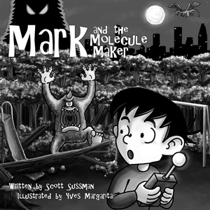  Mark makes a mistake,  then rights the wrong. |  | Fred and the Monster  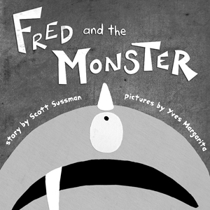  Fred finds the courage  to face his fear of the dark.
Weird the Beard  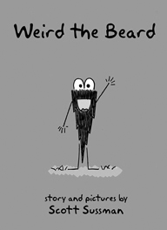  Weird discovers why choosing friends wisely is important. | Mark and the Molecule Maker 2: The Lightning Jungle  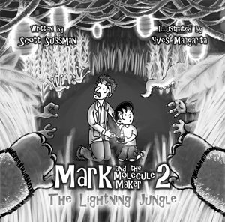  Mark's journey continues  in an amazing new land. | The Shining Adventures  of Shelpa McStorm  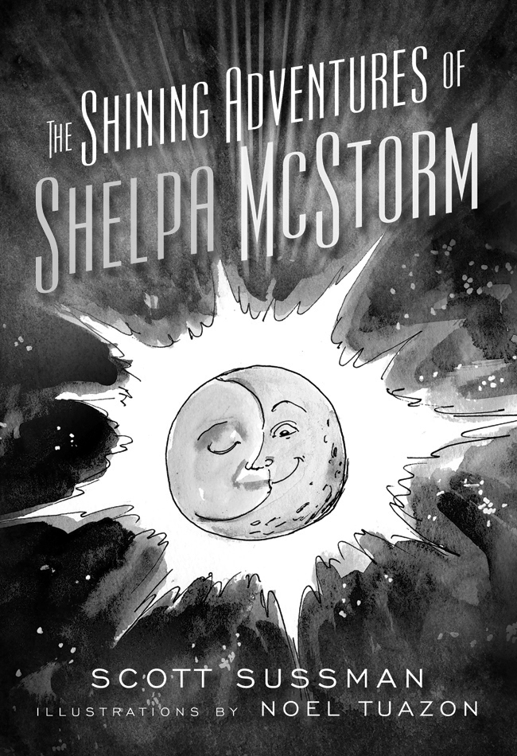  Shelpa's life changes forever during his stay on an amazing vacation planet.  Ages 7-15. 208 pages. $8 (Discounts do not apply.)

BOOK ORDER FORM

(return to teacher or office by Wednesday, January 25th)
All orders must be paid in advance. Cash or Checks accepted. Please make checks payable to Adobe Bluffs PTA.
Books will be distributed on the day of the event.

Please Print First and Last Name of student:_______________________________________________________

Room Number: ________ Teacher:_____________________

Children’s Picture Book Prices: ONE BOOK $15
TWO BOOKS $25 (you save $5)
THREE BOOKS $35 (you save $10)
FOUR BOOKS $45 (you save $15)
FIVE BOOKS $60 (you save $15)

CHILDREN'S PICTURE BOOKS | QTY
SILLY THE SEED
WEIRD THE BEARD
MARK AND THE MOLECULE MAKER
MARK AND THE MOLECULE MAKER 2: The Lightning Jungle
FRED AND THE MONSTER
Total Children Pictures Book ordered
Subtotal | $
CHAPTER BOOK
THE SHINING ADVENTURES OF SHELPA MCSTORM ($8)
Subtotal | $
Order total | $

