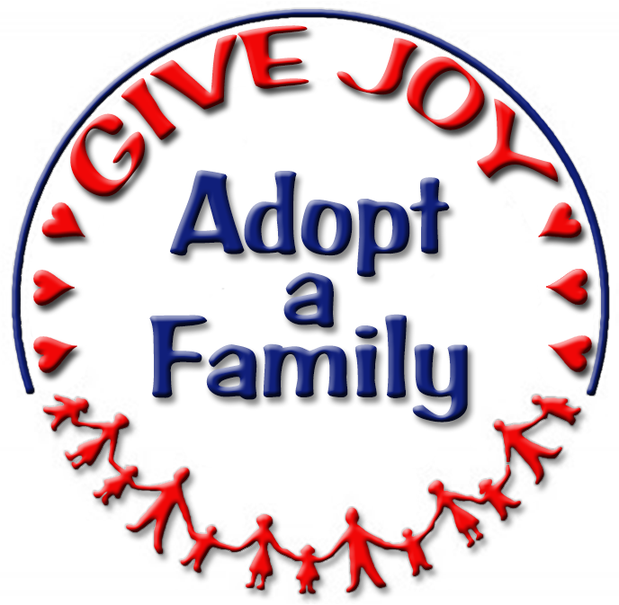
Palomar Council
PTA
everychild.onevoice

Adopt-a-Family, Palomar Council PTA Poway, California 92064

On behalf of the Palomar Council PTA, I would like to thank you for supporting our local families in need through your generous donation of ______________________________ to the 2015 Palomar Council PTA Adopt-a-Family program. This amount represents your purchase of clothing, food, toys, games or household appliances that were provided to needy families through the AAF program.

In these difficult economic times, Poway Unified School District counselors and staff referred 490 families to the Adopt-a-Family program this year. Thanks to contributions like yours, we were able to help families by providing modest gifts and basic necessities to each family member. We also provided grocery gift cards to every family.

Please retain this letter as a formal receipt acknowledging your gift. The Palomar Council PTA is a 501 (c)(3) non-profit organization. Your gift is therefore tax deductible. Our Tax ID number is 23-7038341.

Your contribution has made all the difference to a local family in need. Your donation and support are truly appreciated.

Sincerely yours,

Dorinda Soucek
Adopt-a-Family
Palomar Council PTA Chair

